Mowatt Circle Garden Plant List
6/23/26, no. 5
by Sam Bahr, Horticulturist

The Mowatt Circle Planting was last renovated on October 3, 2023. Many perennials were planted at that time. A few perennials were planted on September 9, 2021. An earlier major renovation was on June 14, 2021, when many perennials were planted. However, the Crape myrtles were installed several years earlier.
Scientific Name | Common Name | Flower Color | Flowering Period | Height | Pollinator Value, Seeding Potential, etc. | (Number of Plants) and location or locations
Acanthus hungaricus | Hungarian Bear’s Breeches |  |  |  |  | (3) D2
Achnatherum calamagrostis; formerly Stipa calamagrostis | Rough Feather Grass |  |  |  |  | (11) C1
Amorpha canescens | Lead Plant |  |  |  | A9, B5, C0, D0, E0, G0, H6, I10, J3, K8, L8, N7 | (4) B4, (7) C4, (2) D4
Amorpha nana | Fragrant False Indigo |  |  |  |  | (2) D2, (9) D3
Anacis x ‘Big Neil (synonym Coreopsis x ‘Big Neil’) | ‘Big Neil’ Hybrid Coreopsis (C. verticillata x C. tripteris) |  |  |  |  | (3) A3, (1) A4, (2) B4, (3) C3
Anacis x ‘Gilded Lace’ (synonym for Coreopsis x ‘Big Neil’) | ‘Gilded Lace’ Hybrid Coreopsis (C. verticillata x C. tripteris) |  |  |  |  | - C4
Baptisia ‘Purple Smoke' | ‘Purple Smoke’ Hybrid False Indigo |  |  |  |  | - B2
Buddleja ‘Grand Cascade’ | ‘Grand Cascade’ Butterfly Bush |  |  |  |  | - C3
Buddleja ‘Pink Cascade II’ | ‘Pink Cascade II’ Butterfly Bush |  |  |  |  | - C2
Buddleja alternifolia | Alternate-leaved Butterfly Bush |  |  |  |  | - B3
Buddleja alternifolia ‘Argentea’ | ‘Argentea ‘Alternate-leaved Butterfly Bush |  |  |  |  | - B4
Buddleja globosa | Chilean Orange Ball Tree |  |  |  |  | - C4, (1) B2
Buddleja x ‘Miss Molly’ | ‘Miss Molly’ Butterfly Bush |  |  |  |  | - A4
Caryopteris x clandonensis ‘Blue Empire’ | Blue Empire False Blue Spirea |  |  |  |  | - B4
Clinopodium vulgare | Wild Basil |  |  |  |  | (13) C4
Crinum (unknown species and cultivar) | Unknown Crinum Lily in location D. |  |  |  |  | - C1
Crinum ‘Carnival’ | ‘Carnival’ Crinum Lily |  |  |  |  | - B1
Crinum ‘Claude Davis’ | ‘Claude Davis’ Crinum Lily |  |  |  |  | - D2
Crinum ‘Fragrant Lady’ | ‘Fragrant Lady’ Crinum Lily |  |  |  |  | - D2
Crinum ‘Lorraine Clark’ | ‘Lorraine Clark’ Crinum Lily |  |  |  |  | - B1
Crinum ‘Summer Glow’ | ‘Summer Glow’ Crinum Lily |  |  |  |  | - D1
Crinum bulbisperum ‘Orange River Strain’ | ‘Orange River Strain’ Crinum Lily |  |  |  |  | - D2, (1) C1
Crinum x herbertii | Milk and Wine Crinum Lily |  |  |  |  | - B1
Crinum x powellii ‘Album’ | ‘Album’ Crinum Lily |  |  |  |  | - C1
Doellingeria umbellata | Flat-topped Aster |  |  |  |  | (3) A1, (5) A2
Elscholtzia stauntonii | Chinese Mint Shrub (seed grown Logee’s strain) |  |  |  |  | (10) B3, (8) D4
Elscholtzia stauntonii ‘Testudo’ | Chinese Mint Shrub ‘Testudo’, cutting grown selection by Sam Bahr |  |  |  |  | (4) A1, (4) A2,  (4) B2
Eragrostis curvula | Weeping Love Grass |  |  |  |  | (5) D1, (5) D2
Iris florentina (Synonym Iris albicans) | Florentine Iris or White Cemetery Iris | white | April 5 - April 18 | 23-29 inches |  | (3) C1
Kolkwitzia amabilis ‘Maradco’ | Dream Catcher Beauty Bush |  |  |  |  | (1) A1, (1) B1
Lagerstroemia indica ‘Whit II’ | Dynamite Crapemyrtle or Dynamite Indian Lilac |  |  |  |  | (1) B2, (1) C2, (1) C3
Lantana camara ‘Citrus Salad’ | ‘Citrus Salad’ Lantana selected by JC Raulston Arboretum |  |  |  |  | (11) A2, (54) A3, (10) A4
Liatris ligulistylis | Meadow Blazing Star |  |  |  |  | (5) D4
Muhlenbergia reverchonii ‘Undaunted’ | ‘Undaunted’ Muhly Grass |  |  |  |  | (4) D2
Nepeta x faassenii ‘Walker’s Deep Blue’ | Catmint ‘Walker’s Deep Blue’ |  |  |  |  | (5) A1
Ribes odoratum ‘Crandall’ | ‘Crandall’ Clove Currant |  |  |  |  | (3) B3
Rosa acicularis, collected in the country Georgia by Dr. Peter Zale | Prickly Wild Rose |  |  |  |  | (1) D3
Rosa x ‘Harrison’s Yellow’ | ‘Harrison’s Yellow’ Rose |  |  |  |  | (1) C2
Sabal minor var. louisiana | Louisiana Palmetto Palm |  |  |  |  | (2) C3
Salvia yangii ‘Blue Spires’ | ‘Blue Spires’ Russian Sage |  |  |  |  | (1) A2
Silphium (unknown species) | Unknown Rosinweed species |  |  |  |  | (1) C1
Silphium asteriscus | Starry Rosinweed |  |  |  |  | (3) D3
Silphium connatum | Appalachian Rosinweed |  |  |  |  | (3) B2
Silphium laciniatum | Compass Plant |  |  |  |  | (4) B2
Silphium mohrii | Mohr’s Rosinweed |  |  |  |  | (5) D2
Solidago altissima, Anniston, Alabama ecotype | Late Goldenrod |  |  |  |  | (8) C3
Solidago altissima, Burlington, Kansas ecotype | Late Goldenrod |  |  |  |  | (8) C2
Sorbaria sorbifolia | Ural False Spirea |  |  |  |  | (1) C2
Stipa extremiorientalis | Feather Grass |  |  |  |  | (5) D2
Teucrium hircanicum ‘Purple Tails’ | ‘Purple Tails’ Iranian Germander |  |  |  |  | (1) C1, (1) C2
Verbascum chaixii ‘Sixteen Candles | ‘Sixteen Candles’ Nettle-leaved Mullein | Light yellow |  |  |  | (5) A1
Verbesina helianthoides | Yellow Crownbeard |  |  |  |  | (10) C3, (3) B2, (3) B3
Vernonia lettermannii ‘Iron Butterfly’ | ‘Iron Butterfly’ Threadleaf Ironweed |  |  |  |  | (1) C4
Vernonia lindheimeri | Wooly Ironweed |  |  |  |  | (1) B4
Vitex agnus-castus ‘V07-SC-OP-4’ | Pink Pinnacle Dwarf Chaste Tree |  |  |  |  | (1) A3
Vitex agnus-castus ‘V12-2-1’ | Rock Steady Chaste Tree |  |  |  |  | (1) B1
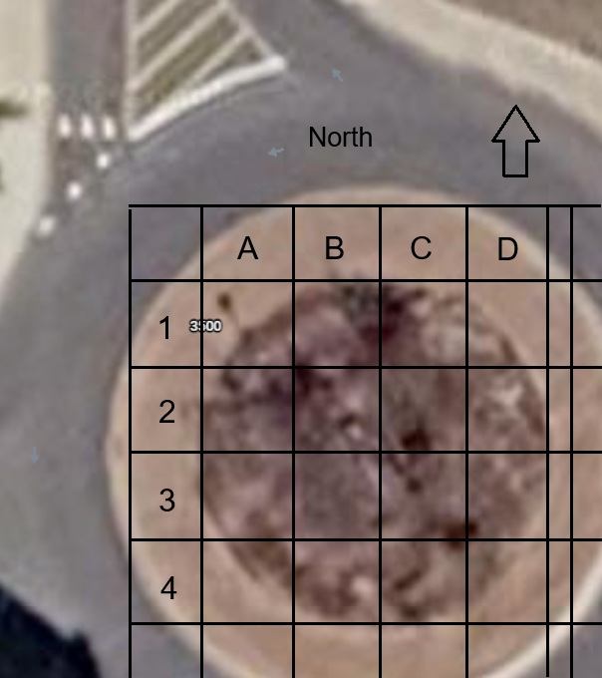
This grid is superimposed over the Mowatt Traffic circle at the intersection of Mowatt Circle and Campus Drive. Mowatt Lane is to the south or at the bottom of the map. To the right of the circle is Campus Drive heading to the east and to the left of the circle is Campus Drive heading west.

